Installation Qualification (IQ)
By approving this document, you confirm that you have completed training on BTSQC09.05 and agree with the contents of this document.

Document Prepared/Reviewed By:
Name and Function | Signature | Date
Kateryna Novodvorska, Author | Captured electronically | Captured electronically

Document Pre-Approvals:
Name and Function | Signature | Date (DD-MON-YYYY)
Gopalan Kannan, ADC Architect | Captured electronically | Captured electronically
Madeline Halliday, SQA | Captured electronically | Captured electronically

Revision History
Document Version # | Revision Date  (DD-MON-YYYY) | Author | Change Request  Number | Change Summary  (Reference section[s] changed)
1.0 | 15-APR-2025 | Kateryna Novodvorska | COM-25-00248 | Initial writing

OVERVIEW

Purpose
This document provides instructions for the installation and qualification of Sales Assist Veeva CRM, version (production) 251.0.201. Acceptance criteria are included to confirm that the hardware and software are installed in accordance with manufacturer guidelines, Abbott BTS specifications and to assure that the installation is qualified.
These installation instructions are developed for the experienced installer.

Scope
This document covers the installation and qualification of the following hardware and software components:
- The software components leverage standard SFDC Platform to install and build components against Abbott business and functional requirements for Sales Assist Veeva CRM Release 25R4 (Veeva 25R1) Enhancements.
- Test Cases not required for this release will be marked as Not Applicable.
- Hardware Component / Version #
- N/A. Sales Assist does not involve installation of Hardware Components.

References
This document references the following documents:
- [COM-25-00248] [SA Veeva] - Change Request Sales Assist Release 25R4 (Veeva 25R1)

Terms and Abbreviations

Reference Abbott Glossary.
Term / Acronym | Definition
N/A | Not Applicable

INDEX OF INSTALLATION TEST CASES
Test Case ID | Test Case Objectives
IQ-001 Case 1 | Hardware / Software Verification – verify minimum hardware and software requirements.
IQ-002 Case 2 | Vendor Package Deployment: Vendor Version upgrade deployed by Veeva
IQ-003 Case 3 | Software Qualification
IQ-004 Case 4 | Software Configuration/Modification

ACCEPTANCE CRITERIA
The execution of this Installation Qualification is accepted if the following conditions are met:
- All steps were executed successfully and supporting artifacts are retained as appropriate.
- Any associated discrepancies have been addressed and resolved.

CASE 1 - HARDWARE / SOFTWARE VERIFICATION
Test Case ID: |  | IQ-001 |  |  |  | Version: |  |  | N/A
Test Case Type: |  | N/A |  |  |  | Run Number: |  |  | N/A
Environment |  | N/A |  |  |  | Installer |  |  | N/A
Objective / Description: |  | N/A
Pre-Requisites: |  | Topic: | N/A
 |  | Topic: | N/A
Item |  | Parameter | Requirement | Actual |  |  | Pass / Fail |  |  |  |  |  | Comments
Hardware |  | Processor | N/A | N/A |  |  | ☐ | Pass | ☐ |  | Fail |  | N/A
 |  | Memory | N/A | N/A |  |  | ☐ | Pass | ☐ |  | Fail |  | N/A
 |  | Disk Space | N/A | N/A |  |  | ☐ | Pass | ☐ |  | Fail |  | N/A
Software |  | Operating System | N/A | N/A |  |  | ☐ | Pass | ☐ |  | Fail |  | N/A
 |  | <Application> Software and Version | N/A | N/A |  |  | ☐ | Pass | ☐ |  | Fail |  | N/A
 |  | <Support> Software | N/A | N/A |  |  | ☐ | Pass | ☐ |  | Fail |  | N/A
Other |  | <Reporting> Tools | N/A | N/A |  |  | ☐ | Pass | ☐ |  | Fail |  | N/A
 |  | Interfaces | N/A | N/A |  |  | ☐ | Pass | ☐ |  | Fail |  | N/A
 |  |  | N/A | N/A |  |  | ☐ | Pass | ☐ |  | Fail |  | N/A
RESULTS
Do install components satisfy system needs and expectations? |  |  |  |  |  |  |  |  | ☐ |  |  | Yes |  | ☐ | No
I have executed these instructions and have appropriately documented the results of the execution and written/referenced Test Defect Reports when needed.
Executed by: | N/A |  |  |  | Date: |  |  |  |  | N/A

CASE 2 – Vendor Version Upgrade Deployment
Test Case ID: |  | IQ-002 |  |  |  | Version: |  |  | N/A
Test Case Type: |  | N/A |  |  |  | Run Number: |  |  | N/A
Environment |  | N/A |  |  |  | Installer |  |  | N/A
Objective / Description: |  | N/A
Pre-Requisites: |  | Topic: |  | N/A
Step | Instruction |  |  |  |  |  | Pass / Fail |  |  |  |  |  |  |  | Comments
1. | N/A |  |  |  |  |  | ☐ | Pass |  |  | ☐ |  | Fail |  | N/A
RESULTS
Does software installation satisfy computer system needs and expectations? |  |  |  |  |  |  |  |  |  | ☐ |  |  |  | Yes |  | ☐ | No
I have executed these instructions and have appropriately documented the results of the execution and written/referenced Test Defect Reports when needed.
Executed By: |  |  | N/A |  | Date: |  |  |  |  |  |  | N/A

CASE 3 – SOFTWARE QUALIFICATION
Test Case ID: |  | IQ-003 |  |  |  | Version: |  |  | N/A
Test Case Type: |  | N/A |  |  |  | Run Number: |  |  | N/A
Environment |  | N/A |  |  |  | Installer |  |  | N/A
Objective / Description: |  | N/A
Pre-Requisites: |  | Topic: |  | N/A
Step | Qualification |  |  |  |  |  | Pass / Fail |  |  |  |  |  |  |  | Comments
1. | N/A |  |  |  |  |  | ☐ | Pass |  |  | ☐ |  | Fail |  | N/A
2. | N/A |  |  |  |  |  | ☐ | Pass |  |  | ☐ |  | Fail |  | N/A
RESULTS
Does software installation satisfy computer system needs and expectations? |  |  |  |  |  |  |  |  |  | ☐ |  |  |  | Yes |  | ☐ | No
I have executed these instructions and have appropriately documented the results of the execution and written/referenced Test Defect Reports when needed.
Executed By: |  |  | N/A |  | Date: |  |  |  |  |  |  | N/A

CASE 4 – SOFTWARE MODIFICATION
Test Case ID: |  | IQ-004 |  |  |  | Version: |  | 1
Test Case Type: |  | Installation |  |  |  | Run Number: |  | 01
Environment |  | ☐ QA ☒ Production |  |  |  | Installer |  | Amy LaForgia - Veeva
Objective / Description: |  | Configure the Sales Assist Veeva CRM App and CRM
Pre-Requisites: |  | Topic: |  | The production environment must be configured for the deployment as per Change Request [COM-25-00248] [SA Veeva] - Change Request Sales Assist Release 25R4 (Veeva 25R1).
Step | Qualification |  |  |  |  |  | Pass / Fail |  |  |  |  |  |  | Comments
1. | Create Package in Click deploy to move over:  Permission set: ADC_Sales_Medical_Inquiry_Intake  Fields on Medical Inquiry:  User Submitter Email  User Submitter Name  User Submitter Type  Delivery Method  Assign to User  Flow: ADC_Send_Email_Alert_MSL  Email Alert: ADC_Email_Assigned_MSL |  |  |  |  |  | ☒ |  | Pass |  | ☐ |  | Fail | N/A
2. | Manually Translate the delivery method options |  |  |  |  |  | ☒ |  | Pass |  | ☐ |  | Fail | N/A
3. | Manually check that Medical Profile does not have access to Med Comm record type on Medical Inquiry object |  |  |  |  |  | ☒ |  | Pass |  | ☐ |  | Fail | N/A
4. | Manually verify that the Credentails field on Account is still valid (changes were made during previous release ensuring field is as expected) |  |  |  |  |  | ☒ |  | Pass |  | ☐ |  | Fail | N/A
5. | Manually inactive flow: ADC_Send_Email_to_Medinfo |  |  |  |  |  | ☒ |  | Pass |  | ☐ |  | Fail | N/A
6. | Manually verify filter on Assign to User on Medical Inquiry object |  |  |  |  |  | ☒ |  | Pass |  | ☐ |  | Fail | N/A
7. | Create a new user called 'ADC Integration User' to route medical intake inquiries to Veeva MedInquiry |  |  |  |  |  | ☒ |  | Pass |  | ☐ |  | Fail | N/A
RESULTS
Does software installation satisfy computer system needs and expectations? |  |  |  |  |  |  |  |  |  |  | ☒ | Yes |  | ☐ | No
I have executed these instructions and have appropriately documented the results of the execution and written/referenced Test Defect Reports when needed.
Executed By: |  |  | Amy LaForgia |  | Date:
OBJECTIVE EVIDENCE:

Installer: Amy LaForgia – Veeva

Test Case IQ-004:

- Create Package in Click deploy to move over:
Permission set: ADC_Sales_Medical_Inquiry_Intake
Fields on Medical Inquiry:
User Submitter Email
User Submitter Name
User Submitter Type
Delivery Method
Assign to User
Flow: ADC_Send_Email_Alert_MSL
Email Alert: ADC_Email_Assigned_MSL

Package Deployment:

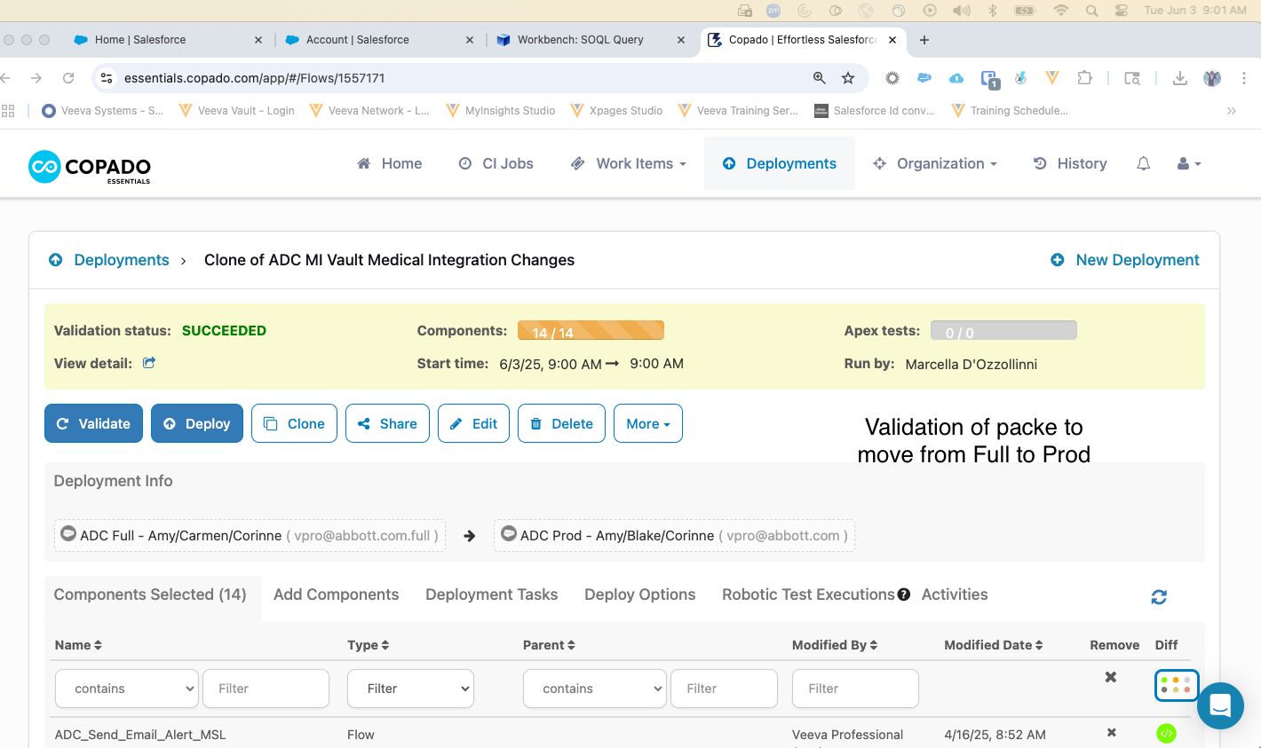

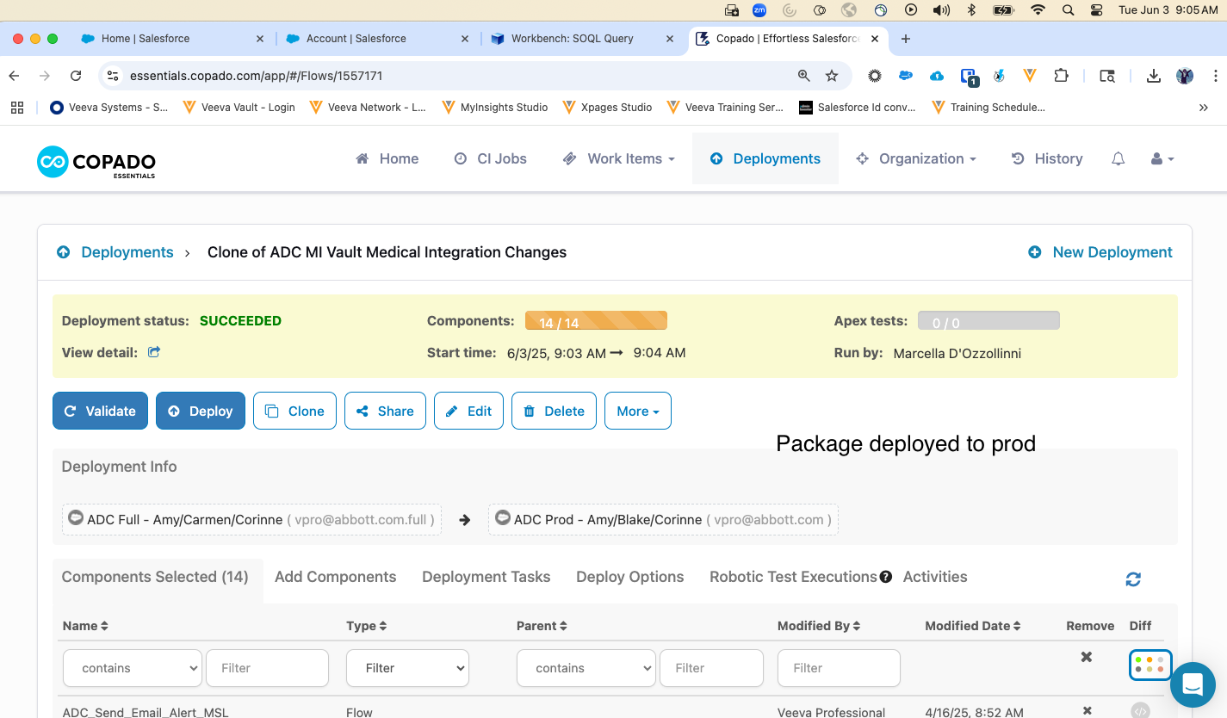

Verification of package components:
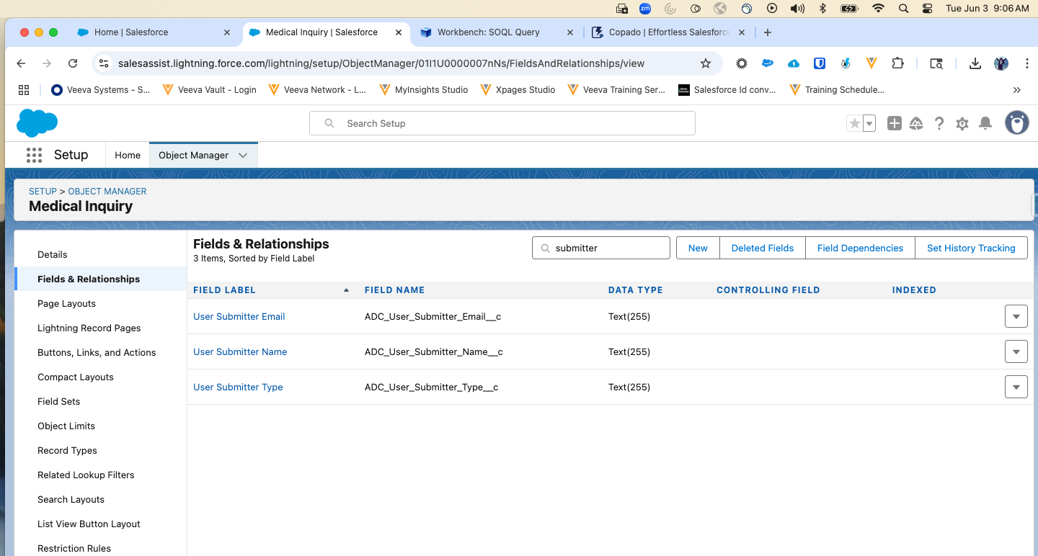
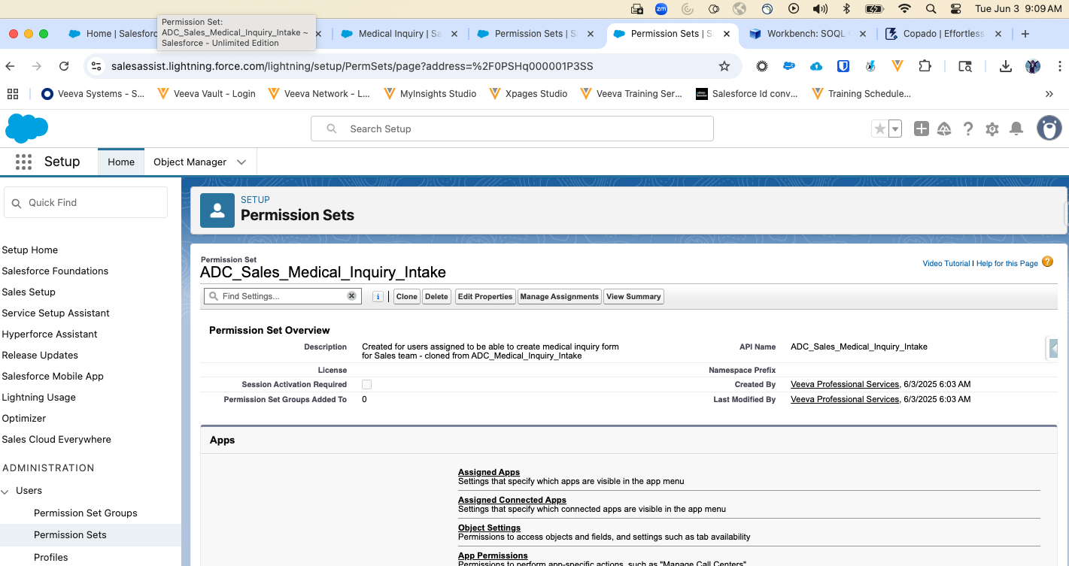

Flow: ADC_Send_Email_Alert_MSL is part of the package.
Email Alert: ADC_Email_Assigned_MSL is part of the package.

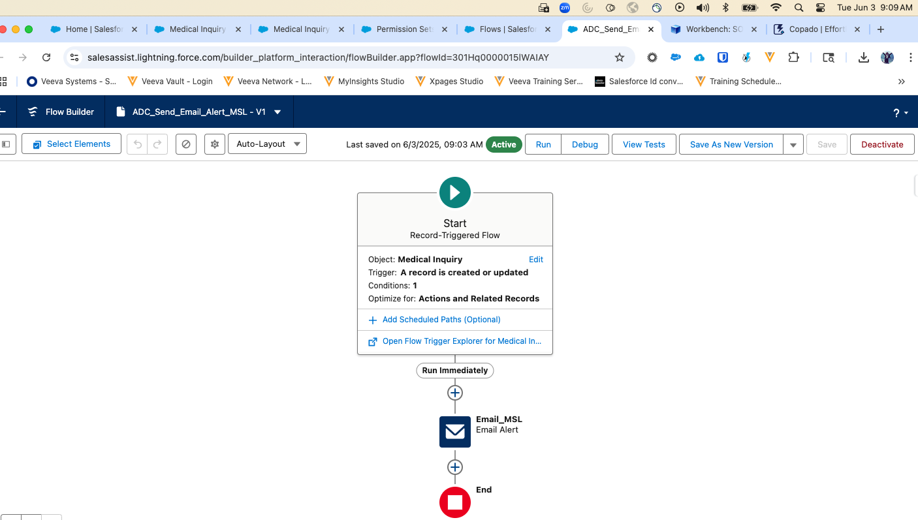

- Manually Translate the delivery method options

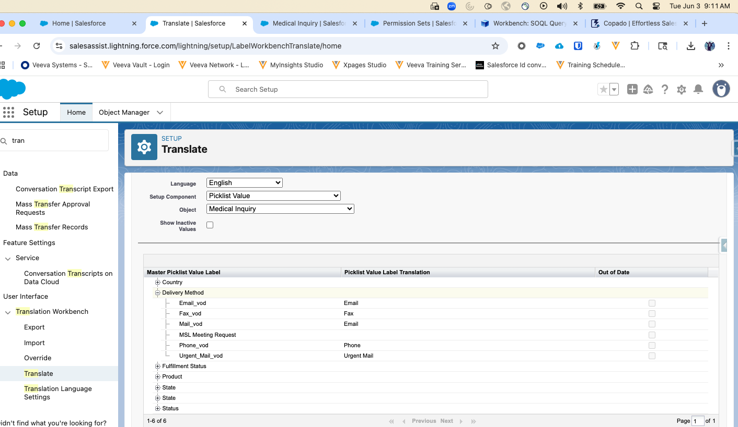
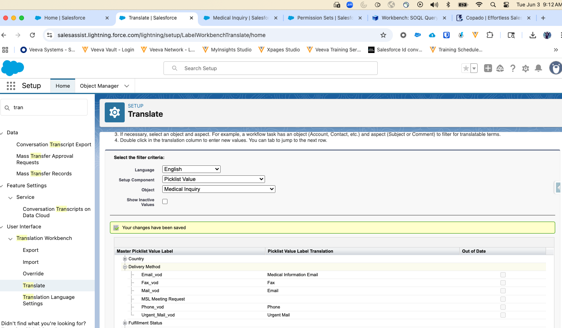

- Manually check that Medical Profile does not have access to Med Comm record type on Medical Inquiry object

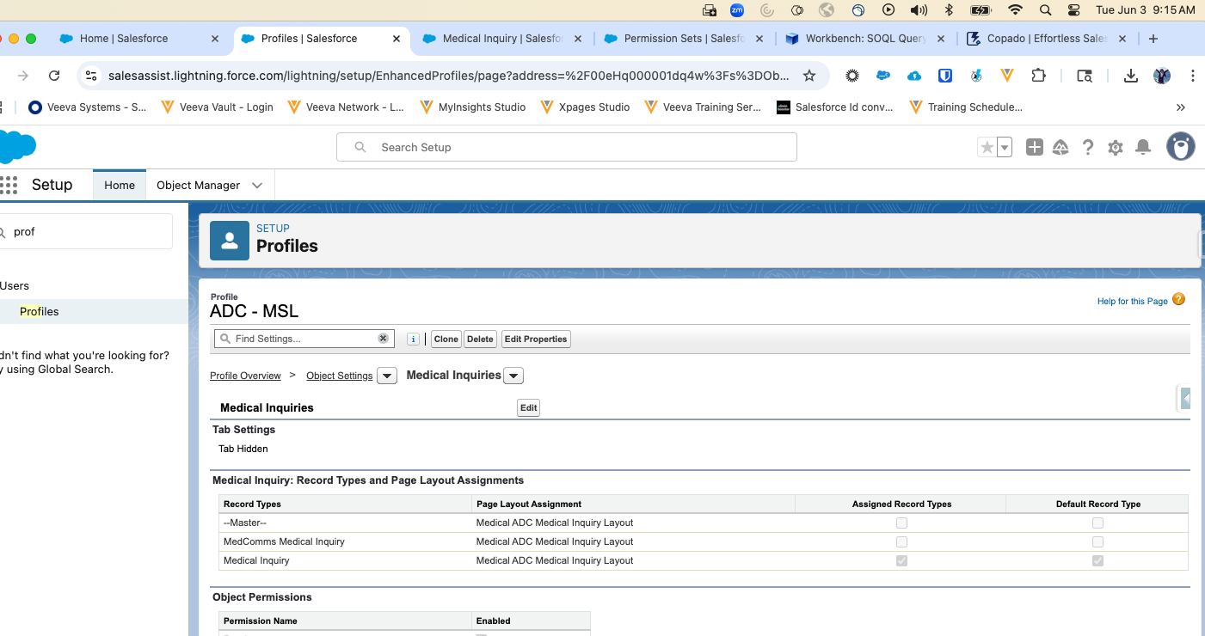

- Manually verify that the Credentials field on Account is still valid (changes were made during previous release ensuring field is as expected)

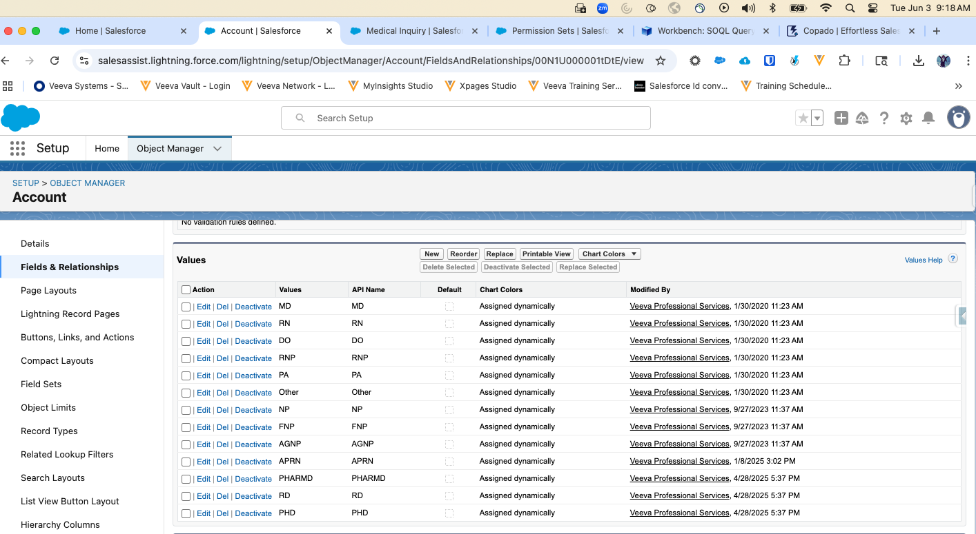

- Manually inactive flow: ADC_Send_Email_to_Medinfo

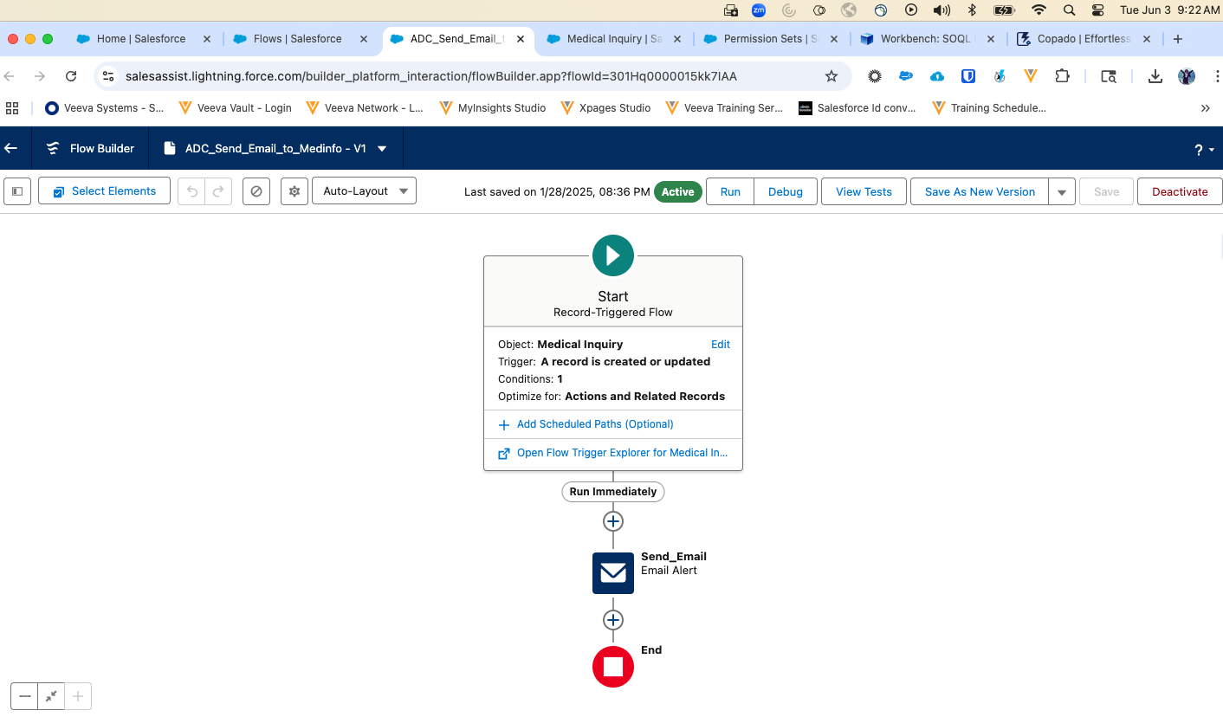
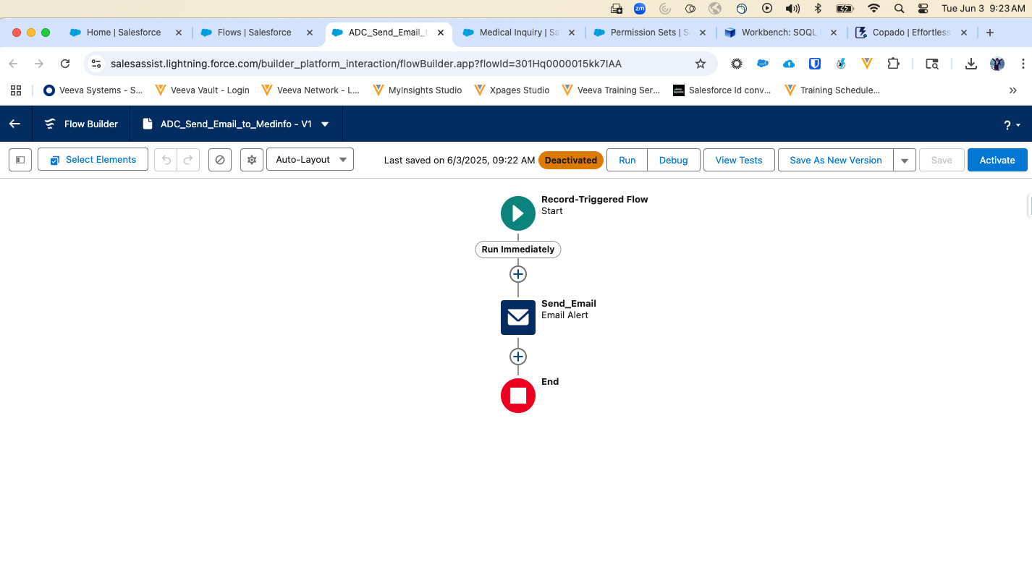

- Manually verify filter on Assign to User on Medical Inquiry object
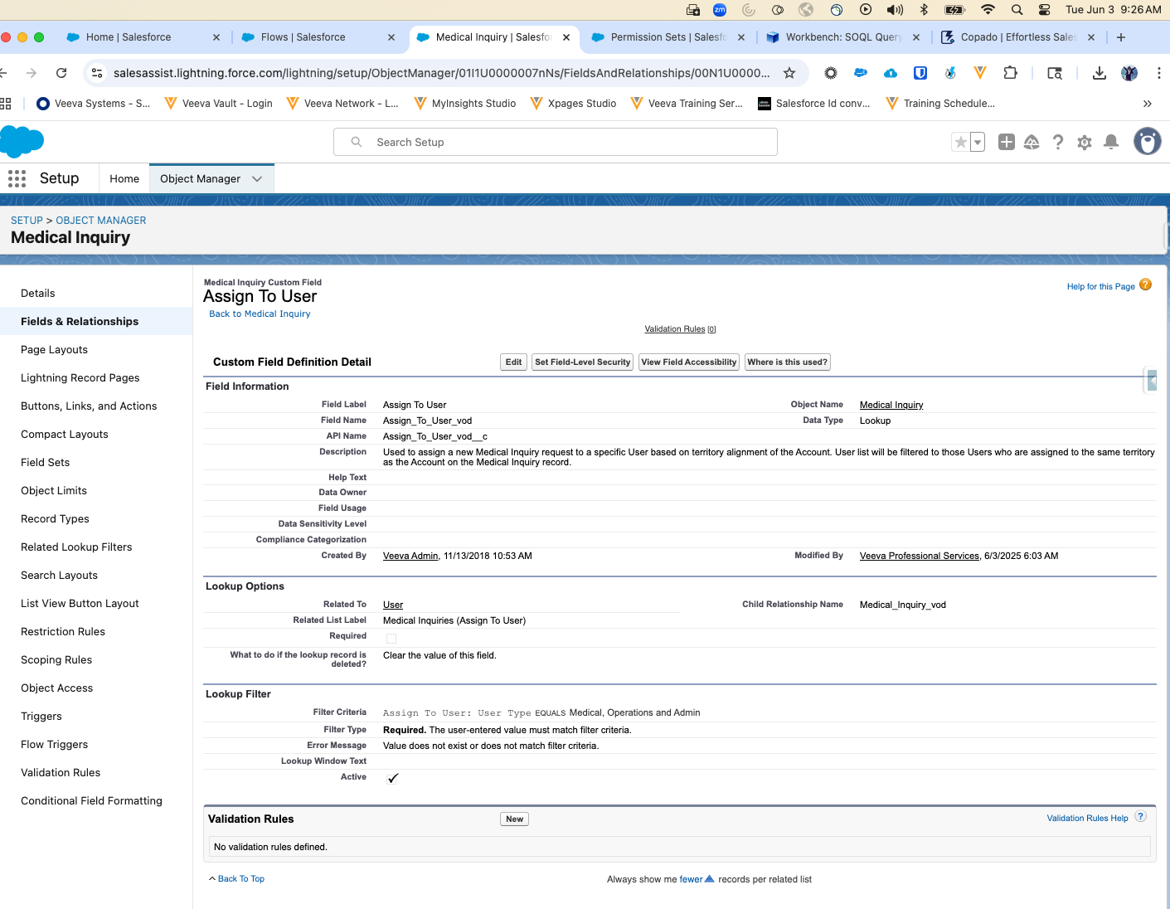

- Create a new user called 'ADC Integration User' to route medical intake inquiries to Veeva MedInquiry.

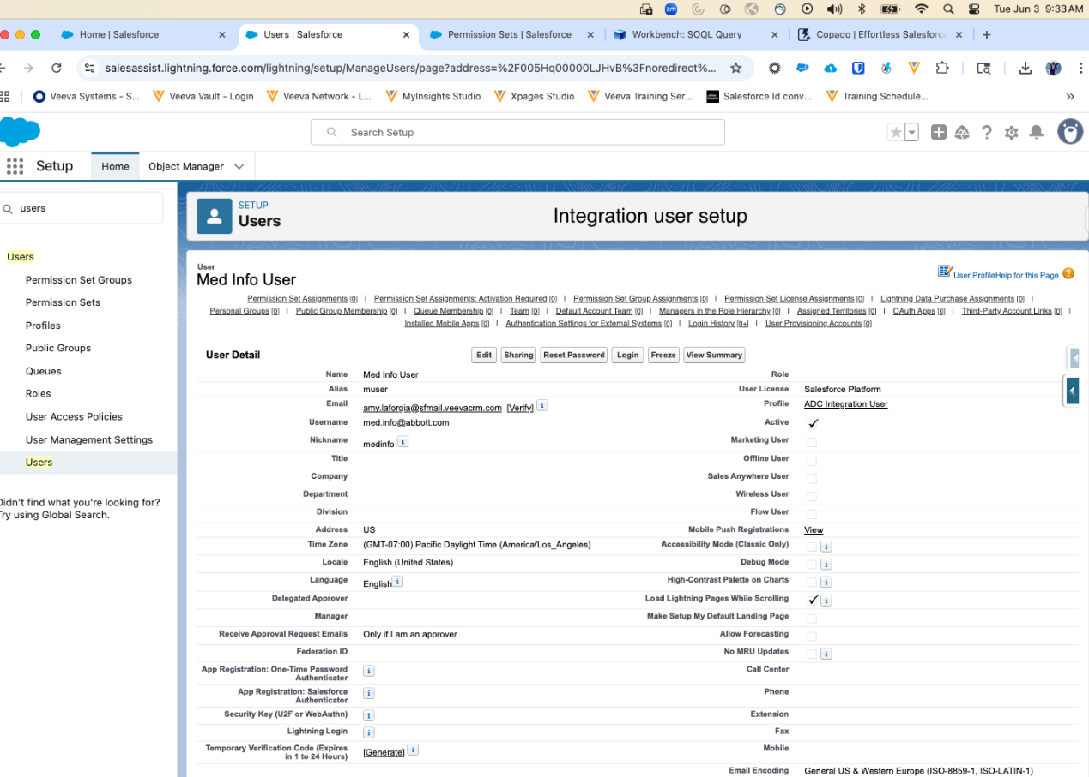
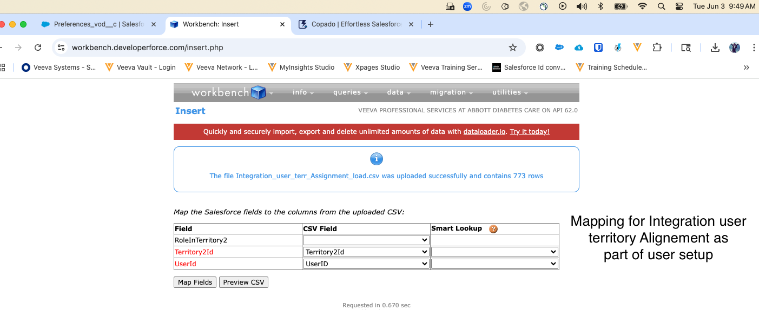
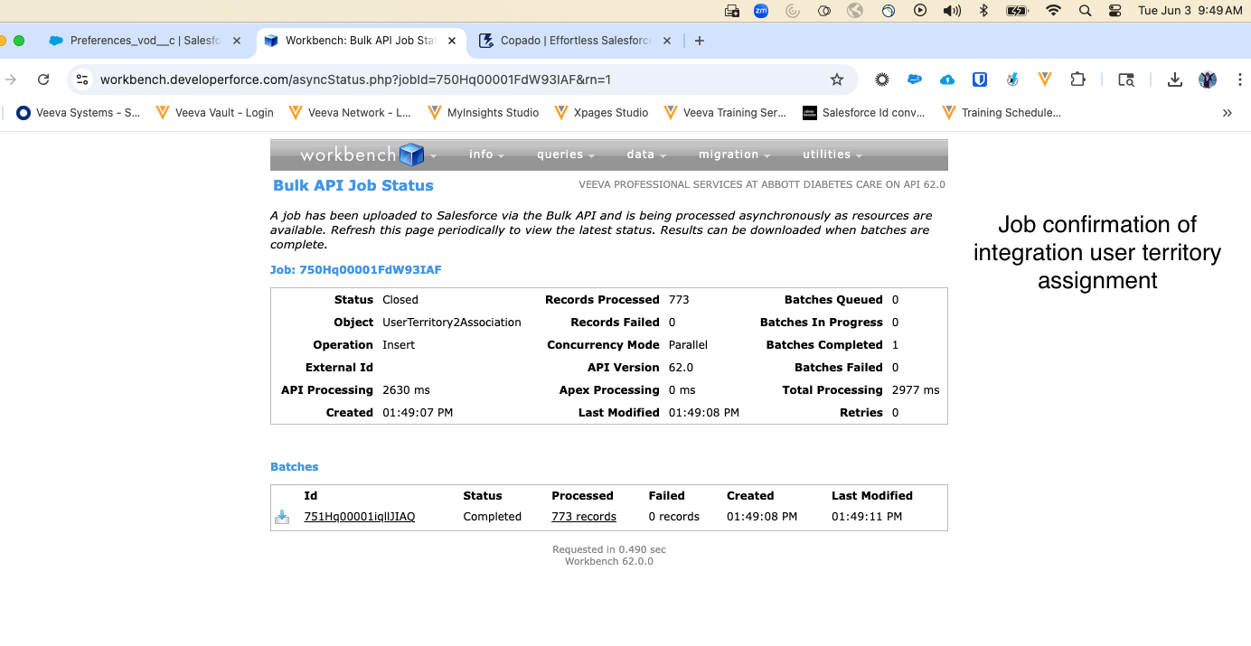

Final Setup look:
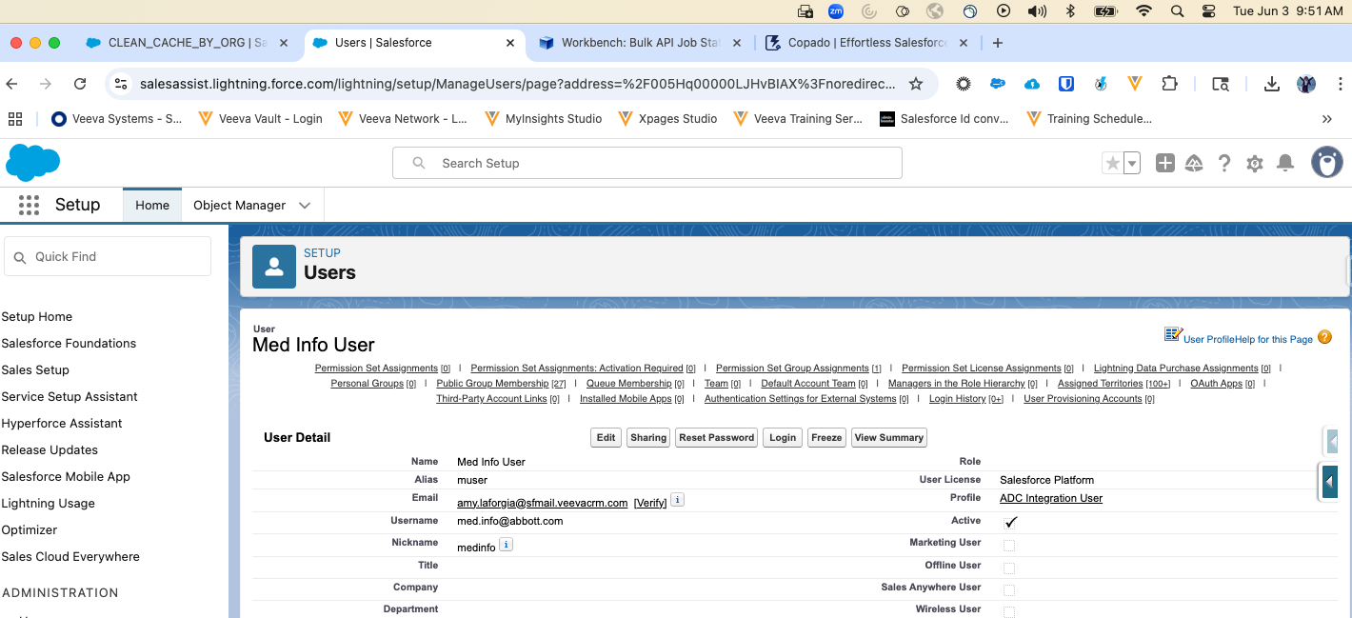

EXECUTION SUMMARY
Execution Summary
Q1- Was the IQ executed without any discrepancy or protocol errors? |  |  |  | ☒ | Yes | ☐ | No
Q2- If the discrepancy or protocol error occurred, IQ update is needed? |  |  |  | ☐ | Yes | ☒ | No
Test Case# | Step# | Tester Comments |  | Note/Resolution
IQ-004 | 1-7 | All steps were executed and passed successfully. |  | N/A
Executed by: Amy LaForgia |  |  | Date:

Reviewer Comments☐ N/A

Reviewed by: Date:

Execution Post-Approvals:
Name and Function | Signature | Date (DD-MON-YYYY)
Gopalan Kannan, Architect | Captured electronically | Captured electronically
Madeline Halliday, SQA | Captured electronically | Captured electronically
END OF document

